Jenkins (master-slave) installation

Ways -

* Manual steps >> installed on ec2 instance - industrial use is not possible; beginner’s guide
* Docker >>
* Terraform >>
* Helm >>
* Ansible >>
* Windows >>

Architecture -

* Jenkins-Github
* Master slave architecture

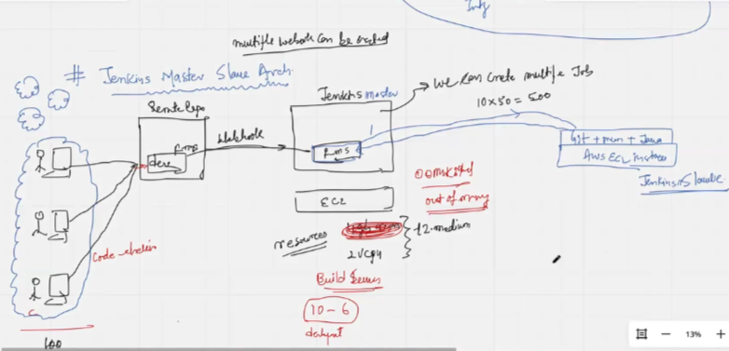

Multiple webhooks can be created

Goto Jenkins >> Build Executor Status >> Built-in Node >> Bring up online >> reboot EC2 >> clear disk usage if rebooting fails

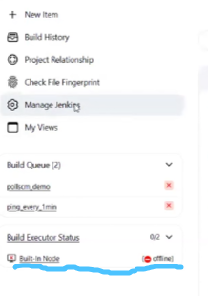

This is a log monitoring and server management tutorial. Looking for server monitoring. In case you see file size high on server directory **/tmp.** Goto IntelliJ >> JenkinsFile >> pipeline >> buildDiscarder - denotes the stored jenkins job history per job.

E.g. 100 jobs having discarder value at 3 shows that total 300 artefacts are stored by Jenkins on server

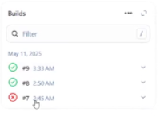

Types of error

* OOM killed - Out of memory killed
* Check data size on /var/lib/jenkins/workspace/ >> du -sh
* Disadvantage recommendations are ACTIVE master and ACTIVE slave even none jobs running on any slave.
* Jenkins master only required. Slave installs only git, maven, java.

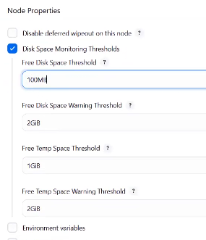

Job requirements

Certifications - AWS+Terraform+Kubernetes

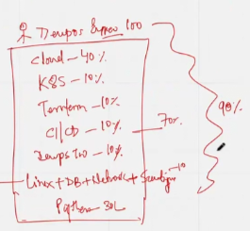

Steps to work with jenkins master slave architecture

**Configuration docx available at greentea/satyam88**

Goto EC2 >> Name=JenkinsSlaveA >> AmazonLinux >> t2.micro >> keypair=same as master

Goto Security >> SecurityGroup >> Inbound traffic >> All traffic

Connect >> Install maven, git, java

* Useradd jenkins-slave-01
* Sudo su - jenkins-slave-01
* Ssh-keygen -t rsa -N “” -f /home/jenkins-slave-01/.ssh/id_rsa
* Cd .ssh
* Cat id_rsa.pub > authorized_keys
* Chmod 700 authorized_keys

Connect JenkinsMaster

* Mkdir -p /var/lib/jenkins/.ssh
* Cd /var/lib/jenkins/.ssh
* Ssh-keyscan -H slave-pvt-ip >> /var/lib/jenkins/.ssh/known_hosts
* Chown jenkins:jenkins known_hosts
* Chmod 700 known_hosts

Configure the slave using Manage Jenkins

Goto Jenkins >> Manage Jenkins >> Nodes >> New node >> Node name=JenkinsslaveA >> Type=Permanent Agent >> Create >> Description=This is a jenkins slave machine >> Number of executors=2 >> Remote root directory=/home/jenkins-slave-01 >> Labels=jenkins-slave-teamA >> Launch method=Launch agents via SSH >> Host=slave-pvt-ip >> Credentials=Add >> Jenkins credentials provider: Jenkins >> Kind=ssh username with private key >> username=jenkins-slave-01 >> Private key >> Enter directly >> Key(/home/jenkins-slave-01/.ssh/id_rsa) ……may display offline and connectivity and launch errors

* Delete the agent
* Bring up the agent of slave
* Reduce disk threshold of online node of master & slave
* Delete EC2 of slave
* Check private and public keys of both host as per defined steps for valid SSH connectivity

Expected output of connectivity between master and slave

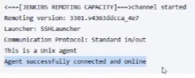

Troubleshooting of connectivity is key

Test connectivity >>

Goto Jenkins >> Manage Jenkins >> Nodes >> Slave nodeA >> Label= jenkins-slave-teamA(copy)

Goto IntelliJ >> Jenkinsfile >> agent {label ‘jenkins-slave-teamA’} ……check jenkins home page for more information - jenkins.io/doc/book/pipeline/syntax/

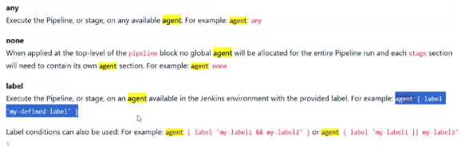

* Git status
* Git diff
* Git add –all; commit; git push origin dev

This will be noted by webhook, trigger jenkins job

Goto Github >> makemytrip26Apr >> delete webhook >> add webhook with latest master ip >> Add webhook

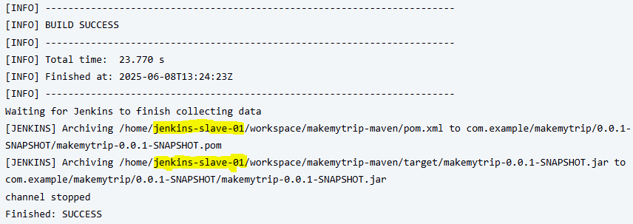

Additional notes

Swap memory v/s ram

Page size in os v/s swap space

Can we have Jenkins-master HA(highly available) like master slave for fault tolerance - Setup Jenkins HA using HA Proxy(or NGINX) as a load balancer and AWS EFS for shared /var/lib/jenkins, providing a solid architecture

<https://www.jenkins.io/doc/book/pipeline/syntax/>

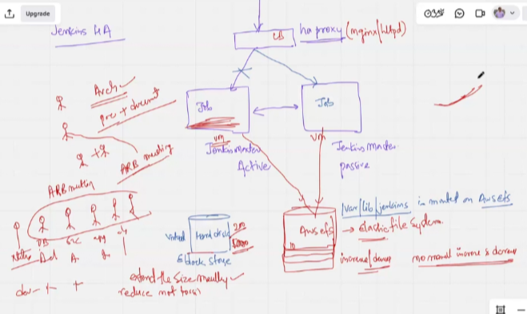

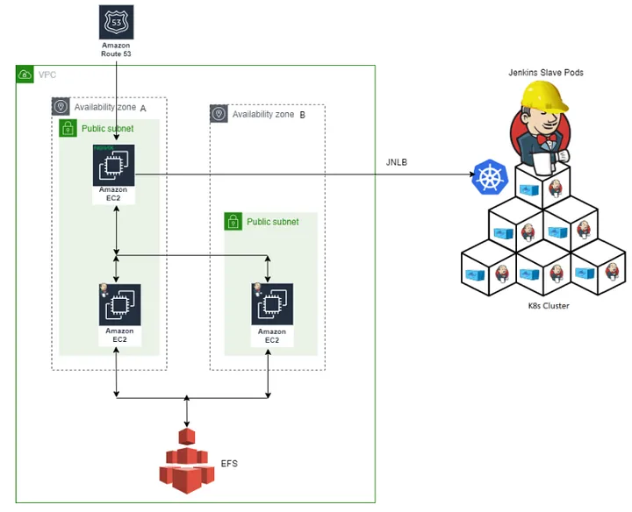

Note

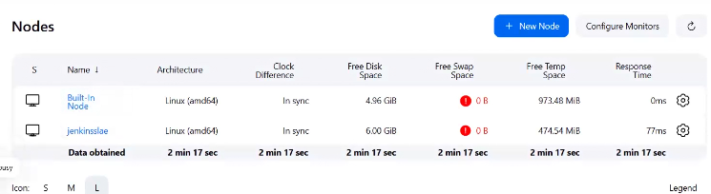

Trouble with nodes is they can say they are offline, always maintaining free temp space below red mark